Chapter 8, Solution 14.
When the switch is in position A, v(0⁻)= 0 and i_{L}(0) = 80/40 = 2 A. When the switch is in position B, we have a source-free series RCL circuit.
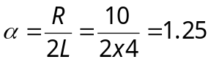
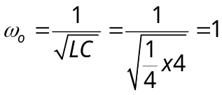

When the switch is in position A, v(0–)= 0. When the switch is in position B, we have a source-free series RCL circuit.

Since 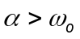, we have overdamped case.

–0.5 and –2

v(t) = Ae^{–2t} + Be^{–0.5t} (1)

v(0) = 0 = A + B (2)

i_{C}(0) = C(dv(0)/dt) = –2 or dv(0)/dt = –2/C = –8.

But 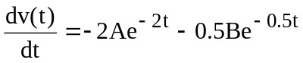

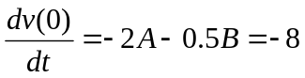 (3)

Solving (2) and (3) gives A= 1.3333 and B = –1.3333

v(t) = 5.333e^{–2t}–5.333e^{–0.5t} V.

